1. **Say "Hello, World!" With C++**

#include <iostream>

#include <cstdio>

using namespace std;

int main() {

    cout << "Hello, World!";

    return 0;

}

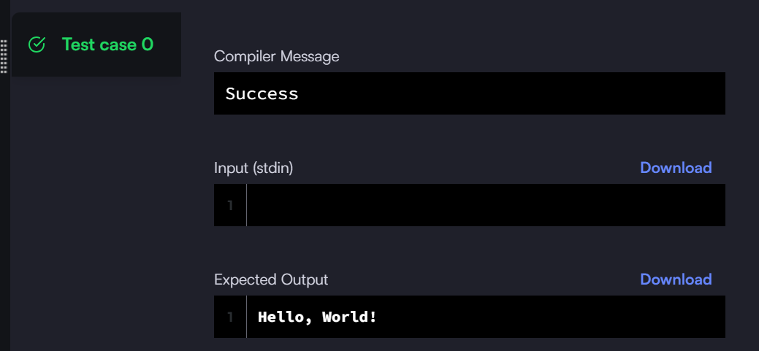

1. **Input and Output**

#include <iostream>

using namespace std;

int main() {

    int a,b,c,sum;

    cin>>a>>b>>c;

    sum = a+b+c;

    cout<<sum;

    return 0;

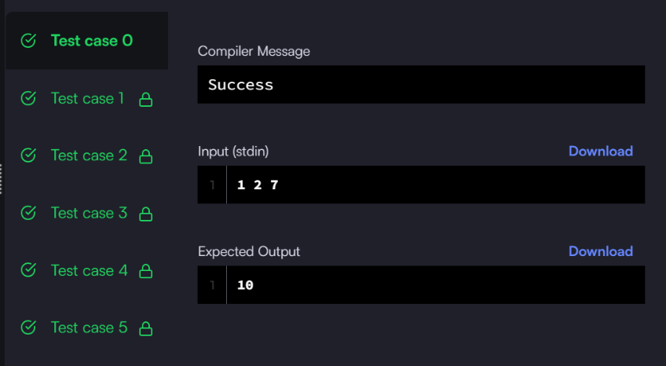}

1. **Basic Data Types**

#include <iostream>

#include <cstdio>

using namespace std;

int main() {

int a;

long b;

char c;

float d;

double e;

cin >> a >> b >> c >> d >> e;

printf("%d\n%ld\n%c\n%f\n%lf\n", a, b, c, d, e);

return 0;

}

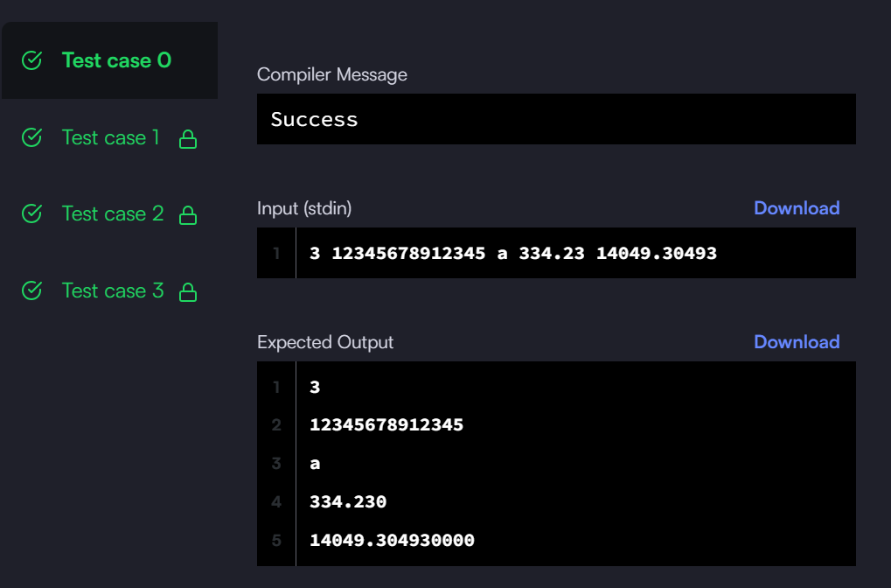

1. **Conditional Statements**

#include <bits/stdc++.h>

using namespace std;

string ltrim(const string &);

string rtrim(const string &);

int main()

{

    string n_temp;

    getline(cin, n_temp);

    int n = stoi(ltrim(rtrim(n_temp)));

    cin >> n;

    if (n == 1) {

        cout << "one";

    } else if (n == 2) {

        cout << "two";

    } else if (n == 3) {

        cout << "three";

    } else if (n == 4) {

        cout << "four";

    } else if (n == 5) {

        cout << "five";

    } else if (n == 6) {

        cout << "six";

    } else if (n == 7) {

        cout << "seven";

    } else if (n == 8) {

        cout << "eight";

    } else if (n == 9) {

        cout << "nine";

    } else {

        cout << "Greater than 9";

    }

    return 0;

}

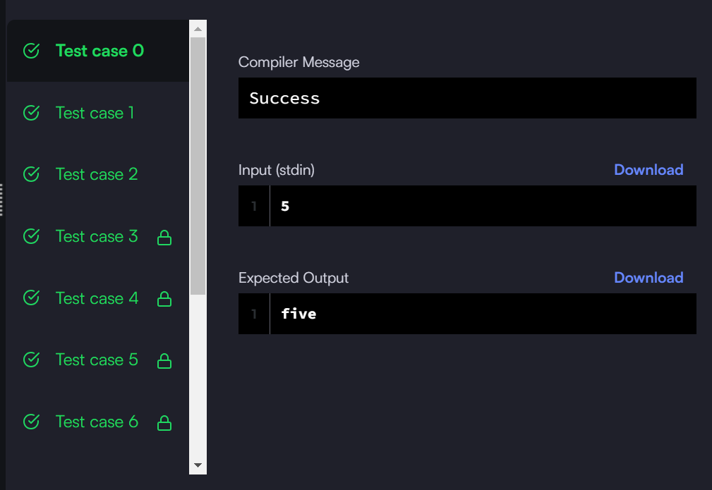

1. **For Loop**

#include <iostream>

#include <cstdio>

using namespace std;

int main() {

     int a, b;

    string num[] = {"zero","one","two","three","four","five", "six","seven","eight","nine"};

    cin >> a;

    cin >> b;

    for (int i = a; i <= b; i++) {

        if (i <= 9) {

            cout << num [i] << endl;

        } else {

            if (i % 2 == 0) {

                cout << "even" << endl;

            } else {

                cout << "odd" << endl;

            }

        }

    }

    return 0;

